Question No: 1
Write a blog on the difference between document and window object.

Difference between document and window:
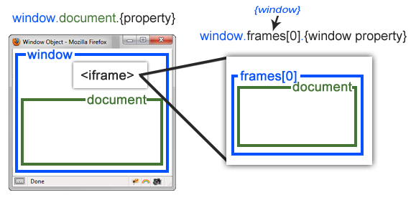
Document | Window Object
It represents any HTML document or web page that is loaded in the browser. | It represents a browser window or frame that displays the contents of the web-page.
It is loaded inside the window. | It is the very first object that is loaded in the browser.
It is the object of window property. | It is the object of the browser.
All the tags, elements with attributes in HTML are part of the document. | Global objects, functions, and variables of JavaScript are members of the window object.
We can access the document from a window using the window. document | We can access the window from the window only. i.e. window.window
The document is part of BOM (browser object model) and dom (Document object model) | The window is part of BOM, not DOM.
Properties of document objects such as title, body, cookies, etc can also be accessed by a window like this window. document.title | Properties of the window object cannot be accessed by the document object.
syntax:  document.propertyname; | syntax:  window.propertyname;
example:  document.title : will return the title of the document | example:  window.innerHeight : will return the height of the content area of the browser
